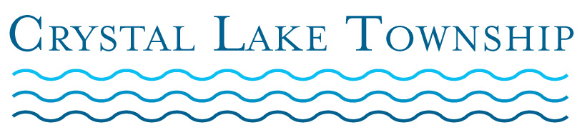
BUDGET HEARING AGENDA
March 12, 2019
6:00 PM

Purpose of the Meeting:

Discussion and Approval of the 2019-20 Fiscal Year Crystal Lake Township Budgets

- Call to Order

- Pledge of Allegiance

- Roll Call

- Adoption of Agenda

- Public Comment

- Salaries & Remunerations Resolutions

- Fund Resolutions
- General Fund
- Cemetery Fund
- Fire & First Responders Fund
- Road Fund

- FY 2019-20 General Appropriations Act Resolution

9. Public Comment

10. Adjournment

